Vision Brief: CoStrategix Context Engine (CCE)

1. Product Vision
CoStrategix Context Engine (CCE) is an enterprise-grade Cross-System Cognitive & Domain Context Mesh. It operates as a platform-agnostic trust boundary positioned between fragmented enterprise systems (data warehouses, communication channels, operational document stores) and any AI agent. By converting enterprise decisions, business logic, and structured metrics into a unified, human-approved semantic fabric, CCE guarantees that every AI interaction is grounded in canonical truth, fully traceable, and continuously proven through live dual-execution benchmarks.

2. Product Promise
CCE guarantees that no AI agent across the enterprise acts on unverified assumptions, hallucinated metrics, or domain ambiguity. It promises a universal, real-time context layer that delivers a proven accuracy lift ($\ge 80\%$ precision on complex queries), enforces strict human-in-the-loop governance, and manages domain-specific context packages that can be authored, validated, and hot-swapped without altering core engine infrastructure.

3. Problem Statement: The Enterprise Domain Context Crisis
Modern enterprise AI initiatives fail not due to model limitations, but due to a profound context and domain breakdown:
- The "Chat With Your Data" Fallacy: Ungoverned RAG systems retrieve raw text chunks and force LLMs to guess business terms, producing plausible-but-wrong SQL queries and hallucinated operational metrics.
- The Fragmented Context Gap: Over $80\%$ of enterprise context resides outside data warehouses—hidden in Gmail threads, Slack discussions, Google Docs SOPs, and customer contracts. Warehouses store the numbers, but operational channels hold the business rationale.
- Multi-Domain Ambiguity Collision: The same term means radically different things across different business units within the same enterprise (e.g., "ARR" in SaaS vs. "ARR" in Logistics, or "On-Time Delivery" in Retail vs. "On-Time Delivery" in Enterprise Express).
- Black-Box Context Quality: Enterprise leaders have no mechanism to evaluate whether injecting retrieval context actually improves AI accuracy or introduces subtle hallucinated risks.

4. Strategic Purpose

To establish the Universal Trust & Domain Governance Infrastructure for enterprise artificial intelligence. CCE decouples business domain logic from both data storage tiers and AI model providers. It ingests raw operational knowledge, enforces human approval, structures domain-specific intelligence into isolated and inheritable context packages, and exposes deterministic context to internal analysts and autonomous AI agents alike.

5. Strategic Advantage: Winning Over Cloud Warehouse Context Layers
While cloud warehouse providers promote built-in context tools (e.g., Snowflake Horizon/Cortex, Databricks Unity Catalog AI), their architectures suffer from inherent single-vendor boundaries. CCE wins through five structural advantages:
THE CCE STRATEGIC ADVANTAGE

SNOWFLAKE HORIZON / DATABRICKS | COSTRATEGIX CONTEXT ENGINE (CCE)
Single-Cloud Vendor Lock-In | Neutral, Cross-System Mesh (Snowflake + Databricks + M365)
Warehouse Data Focus Only | Cross-Modal Fusion (Warehouse Numbers + Workspace Rationale)
Intra-Platform Agent Binding | Open Protocol Interoperability (Universal MCP Broker)
Passive Metadata Tagging | Active Epistemic Proof (Context OFF vs ON Live Lift)
Hardcoded Schema Mappings | Swappable, Multi-Domain Context Packages & Inheritance
Direct Machine Ingestion | Propose-Only Human Governance Firewall
- Platform-Agnostic Neutrality: Snowflake and Databricks only govern assets inside their proprietary clouds. CCE sits above the data tier, unifying Snowflake, Databricks, BigQuery, Google Workspace, Microsoft 365, and Salesforce into a single semantic graph.
- Cross-Modal Context Fusion: Warehouse catalogs only understand schemas and transformation pipelines. CCE fuses structured warehouse metrics with unstructured operational intent (e.g., combining Snowflake revenue tables with Gmail customer contract grace-period exceptions).
- Deep Multi-Domain Package Isolation: CCE keeps the core engine completely domain-blind. Business domains (Logistics, Healthcare, FinTech, SaaS) are encapsulated into modular, version-controlled Context Packages that can be loaded, inherited, or overridden at runtime.
- Active Epistemic Proof (Context OFF vs. ON Engine): CCE continuously executes dual-path queries (Context OFF baseline vs. Context ON governed), proving accuracy lift live on every question.
- Universal MCP Agent Interoperability: CCE acts as a Model Context Protocol (MCP) server, serving governed domain context to Claude, OpenAI, Gemini, Cursor, or custom internal micro-agents without custom point-to-point integrations.

6. Domain Context Architecture: Core vs. Swappable Domain Packages
The core philosophy of CCE is Domain-Blind Core + Modular Domain Packages. The core runtime possesses zero hardcoded business terms; all business concepts, metrics, and relationships live inside isolated, versioned domain context packages.
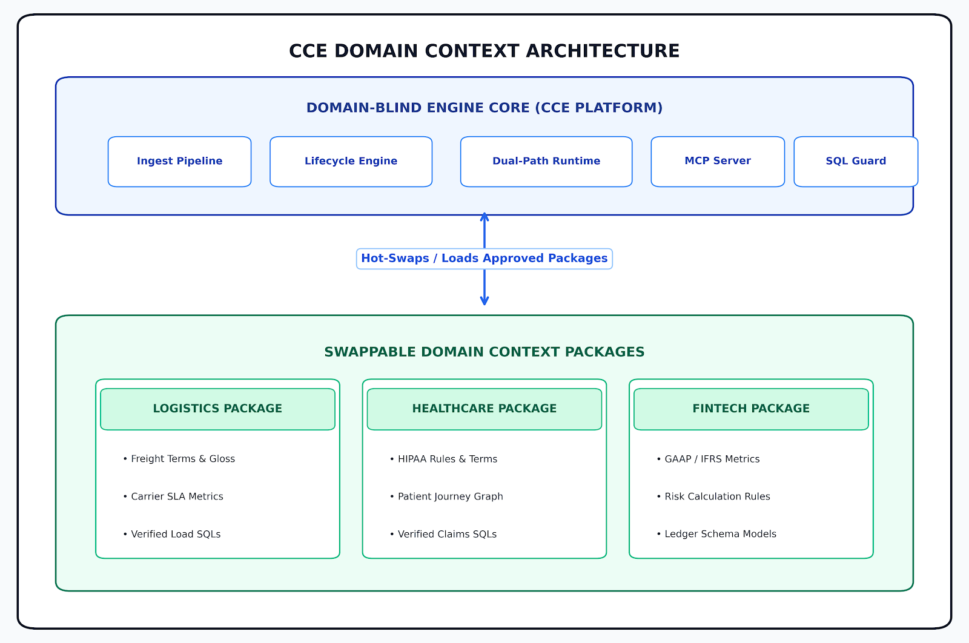

Components of a Domain Context Package
- Domain Glossary: Approved canonical terms, synonyms, and acronyms specific to the domain.
- Domain Semantic Model: Logical-to-physical mappings connecting business concepts to warehouse views and columns.
- Domain Entity Graph: Entity-relationship topology defining operational relationships (e.g., Customer -> Order -> Lane -> Carrier -> Invoice).
- Verified SQL Library: Human-blessed query templates optimized for domain-specific metrics.
- Domain Policy & SOP Rules: Operating procedures, regulatory constraints, and customer-specific SLA overrides.
- Domain Ambiguity Register: Record of conflicting domain terms pinned to canonical definitions and alternative interpretations.

7. Hierarchical Domain Context Inheritance & Override Engine
Enterprises operate at multiple organizational tiers. CCE manages domain context through a 4-tier Inheritance & Override Hierarchy, allowing enterprise-wide policies to cascade down while permitting domain-level and account-level overrides without breaking core definitions.
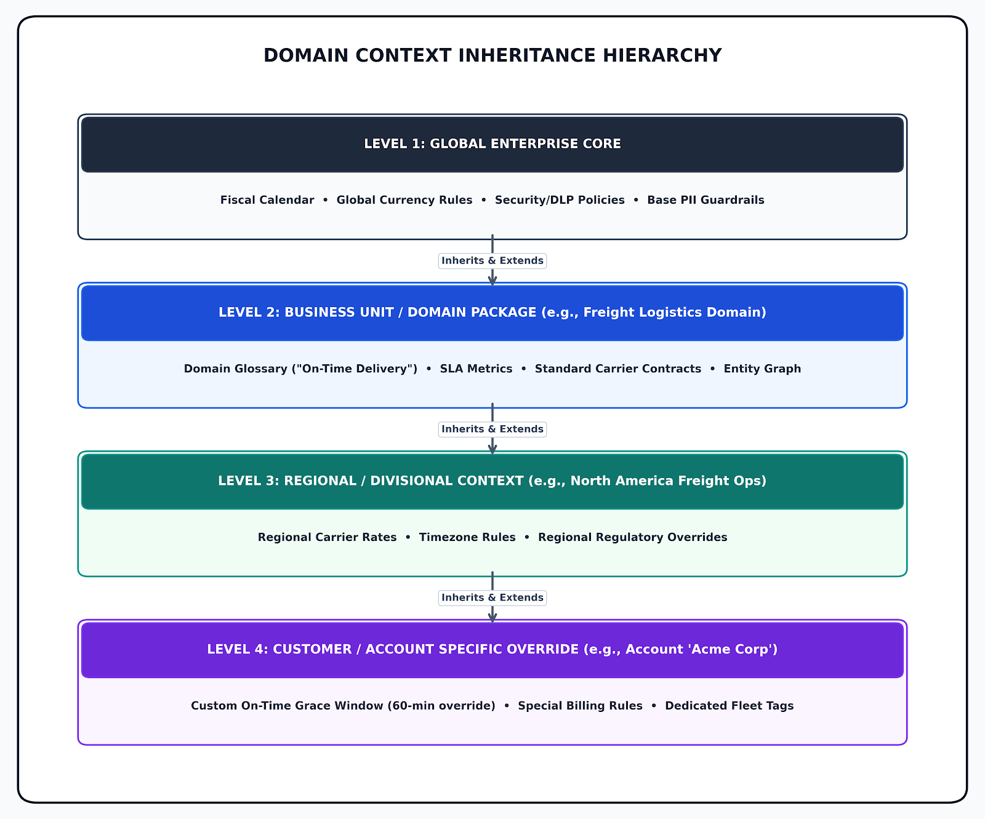

Key Hierarchy Levels Breakdown
- Level 1: Global Enterprise Core: Establishes organization-wide defaults including fiscal calendars, security/DLP policies, global currency rules, and base PII redaction guardrails.
- Level 2: Business Unit / Domain Package: Extends global rules into specific operational domains (e.g., Logistics, Healthcare, FinTech) with canonical glossaries, SLA metrics, and entity graphs.
- Level 3: Regional / Divisional Context: Refines domain rules with geographic or division-specific parameters such as regional carrier tariffs, local regulatory overrides, and timezone boundaries.
- Level 4: Customer / Account Specific Override: Handles granular account-level overrides (such as account-specific grace windows or billing policies) without modifying upstream canonical definitions.

8. Target Customers
- Multi-Domain Enterprises: Organizations operating multiple complex business divisions (e.g., Logistics, FinTech, Healthcare) requiring isolated yet interoperable domain governance.
- High-Growth Product & Data Teams: Engineering teams replacing ad-hoc RAG setups with governed context infrastructure.
- Regulated & Audit-Heavy Industries: Organizations requiring complete source lineage, explicit citations, DLP enforcement, and zero-hallucination execution guarantees.

9. Primary Users & Role Matrix
User Role | Core Domain Responsibilities | Primary Platform Interface
Domain Owner / Steward | Authors domain packages, resolves term ambiguities, approves canonical definitions. | Business Glossary & Ambiguity Register.
Domain Analytics Engineer | Binds domain metrics to warehouse schemas, curates verified SQL templates. | Semantic Model Studio & Verified SQL Library.
Enterprise AI Architect | Configures domain scopes, manages MCP tool endpoints, assigns agent context budgets. | MCP Broker & Multi-Domain Topology Console.
Business / Data Analyst | Executes natural language queries, verifies Context OFF vs ON accuracy lift, inspects lineage. | Analyst Proof Web Application.

10. Desired User Experience
- Side-by-Side Epistemic Proof Workspace: A dual-column interface displaying Context OFF (ungoverned baseline) alongside Context ON (governed context), explicitly highlighting generated SQL, resolved terms, active domain package versions, citations, and confidence scores.
- Domain Context Studio: A visual dashboard for managing domain context packages, inspecting term inheritance, and resolving cross-domain term collisions.
- One-Click Human Governance Queue: An inbox-style approval interface for domain stewards to review machine-proposed terms and promote them to approved status in seconds.

11. Input Experience & Cross-Modal Grounding
CCE ingests raw knowledge through read-only, least-privilege connectors:
- Operational Communication (Business Rationale): Gmail Enterprise, Slack, Google Docs, and Microsoft Teams provide decisions, SOPs, customer commitments, and policy rules.
- Structured Warehouse Telemetry (Business Numbers): Snowflake, Databricks, PostgreSQL, and BigQuery schemas provide tables, views, and execution metadata.
- Extraction & Classification: Ingestion connectors chunk content, execute DLP/PII redaction, capture entitlements, and extract candidate entities into vector and graph indices.
- The Proposal Landing Gate: All ingested metadata lands strictly in a proposed state—completely isolated from the query engine until human approval.

12. Major Flow: The Cross-System Cognitive Pipeline

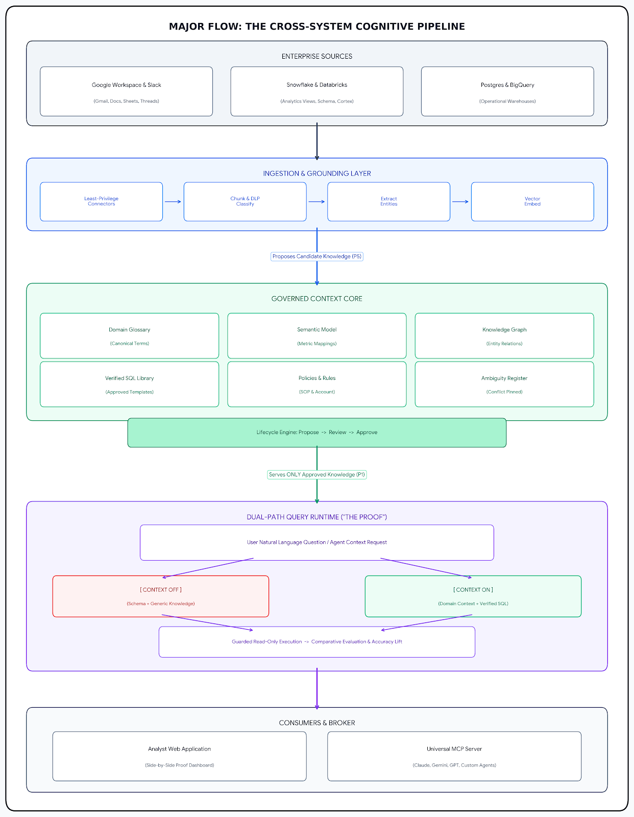

Pipeline Stage Summary
- Enterprise Sources: Unifies structured warehouse telemetry (Snowflake, Databricks, Postgres, BigQuery) with unstructured communication and operational intent (Google Workspace, Slack, Gmail, Docs).
- Ingestion & Grounding Layer: Connects via least-privilege APIs, chunks content, executes DLP/PII classification, extracts graph entities, and generates vector embeddings.
- Governed Context Core: Implements a strict proposal firewall (Propose -> Review -> Approve), serving only human-approved glossaries, semantic models, graphs, and verified SQL templates.
- Dual-Path Query Runtime ("The Proof"): Concurrently executes Context OFF (ungoverned baseline) and Context ON (governed domain context + verified SQL) queries to quantify accuracy lift and eliminate hallucinated results.
- Consumers & Broker: Exposes governed domain context to analysts via the proof web application and to autonomous AI agents via the Model Context Protocol (MCP) server.

13. Excellence Standard & Epistemic Metrics
- Approved-Only Invariant: $100\%$ of context served to query runtime or MCP endpoints must have status=approved.
- Benchmark Accuracy Lift: Context ON must achieve $\ge 80\%$ accuracy on benchmark evaluation suites, compared to $\le 40\%$ for Context OFF.
- Complete Lineage Traceability: $100\%$ of statements, metrics, or generated SQL queries must include source-level citations and version tags.
- Guarded Execution Isolation: All warehouse operations are restricted to read-only SELECT queries with statement timeouts and strict result row caps.

14. Digital Asset & Knowledge Studio: CoS Context Lifecycle
The Digital Asset & Knowledge Studio governs the end-to-end lifecycle of enterprise context assets.
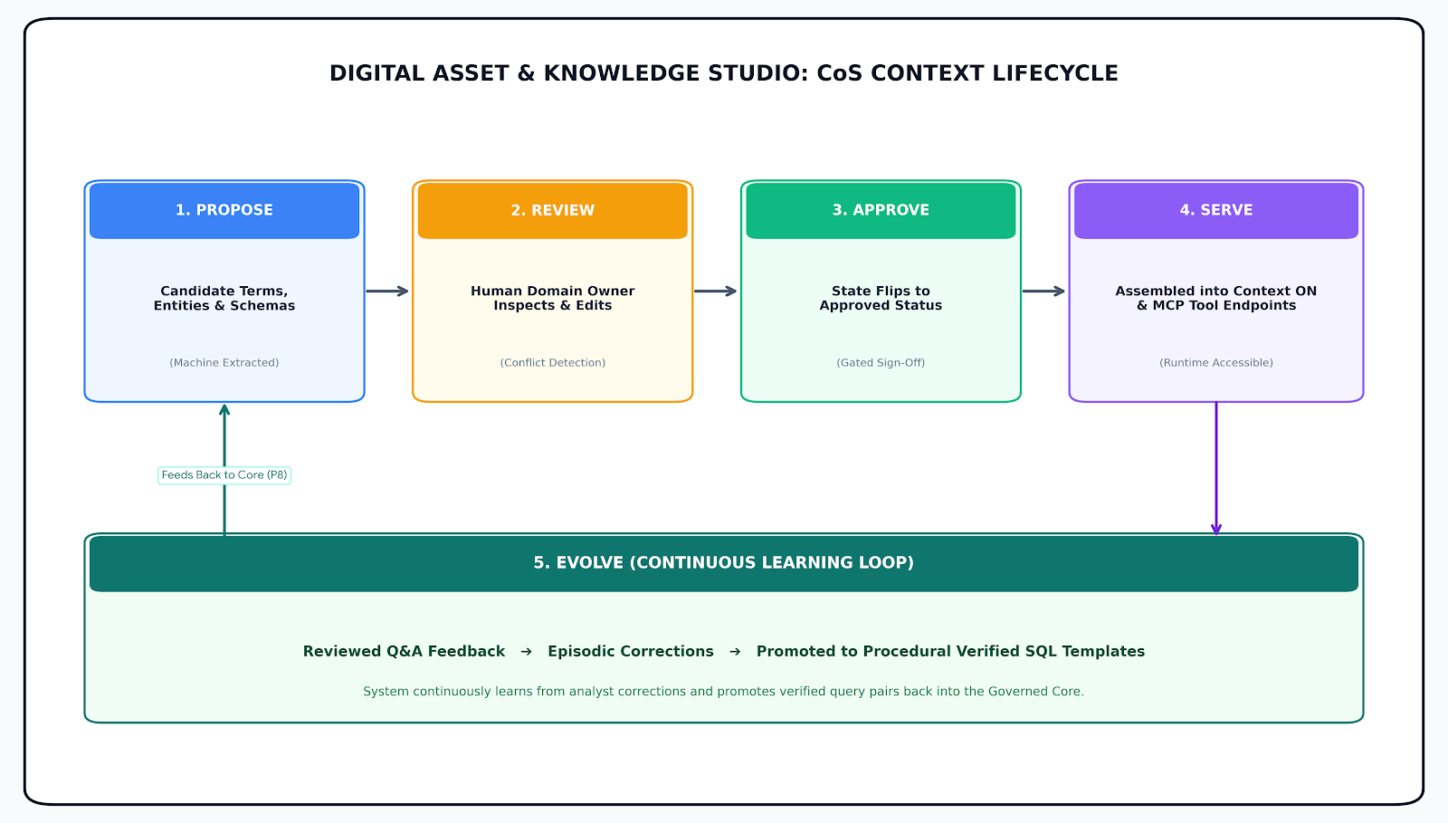

Core Stages of the Lifecycle
- 1. Propose: Machine ingestion connectors extract candidate terms, entities, and semantic mappings, placing them strictly into a proposed status.
- 2. Review: Human domain leads inspect, edit, resolve term ambiguities, and eliminate conflicting definitions.
- 3. Approve: The asset state flips to approved, allowing it to cross the governance firewall.
- 4. Serve: Approved knowledge is assembled into Context ON prompt packages and exposed via Model Context Protocol (MCP) tool endpoints.
- 5. Evolve (Learning Loop): Analyst Q&A feedback and corrections are captured into episodic memory and automatically promoted to procedural verified SQL templates, closing the feedback loop back into the core.

15. Multi-Domain Context Orchestration & Isolation Flow
When a user or AI agent queries CCE, the Domain Orchestration Router dynamically resolves domain scopes, enforces boundary isolation, applies inheritance rules, and handles ambiguity resolution.
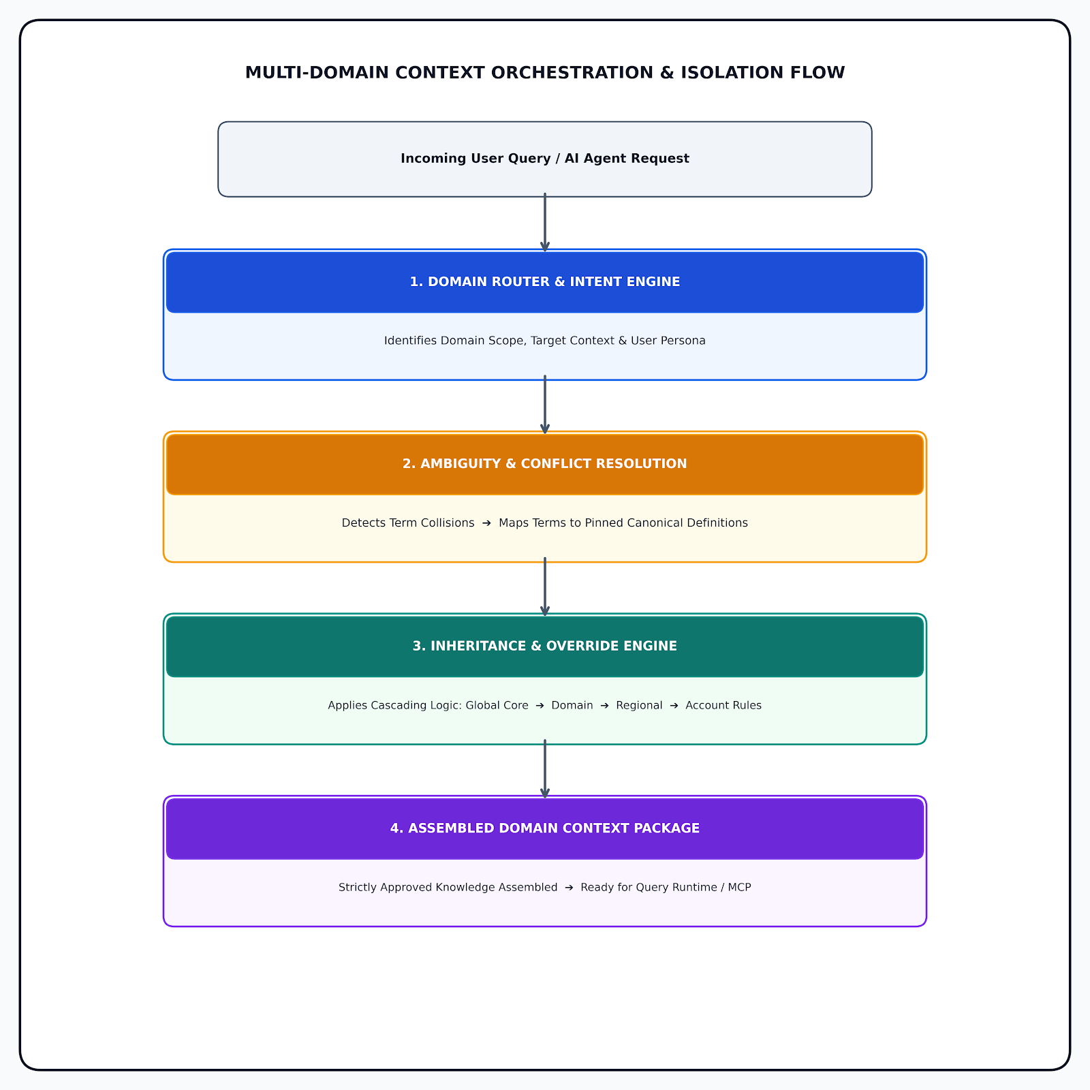

Flow Stages Breakdown
- Domain Router & Intent Engine: Parses the incoming natural language request or AI agent tool call to identify target domain scope, required context depth, and user role persona.
- Ambiguity & Conflict Resolution: Scans for conflicting definitions across domains and maps surface terms directly to pinned canonical meanings in the ambiguity register.
- Inheritance & Override Engine: Evaluates cascading context rules from Global Enterprise Core down through Business Unit, Regional Division, and Account-specific overrides.
- Assembled Domain Context Package: Assembles a domain-bound context package containing only human-approved assets, ready for dual-path query execution or MCP server serving.

16. Multi-Agent Interoperability via MCP Broker
CCE treats context as a reusable enterprise utility exposed via the Model Context Protocol (MCP). External AI agents do not access underlying databases directly; instead, they consume governed domain context tools:
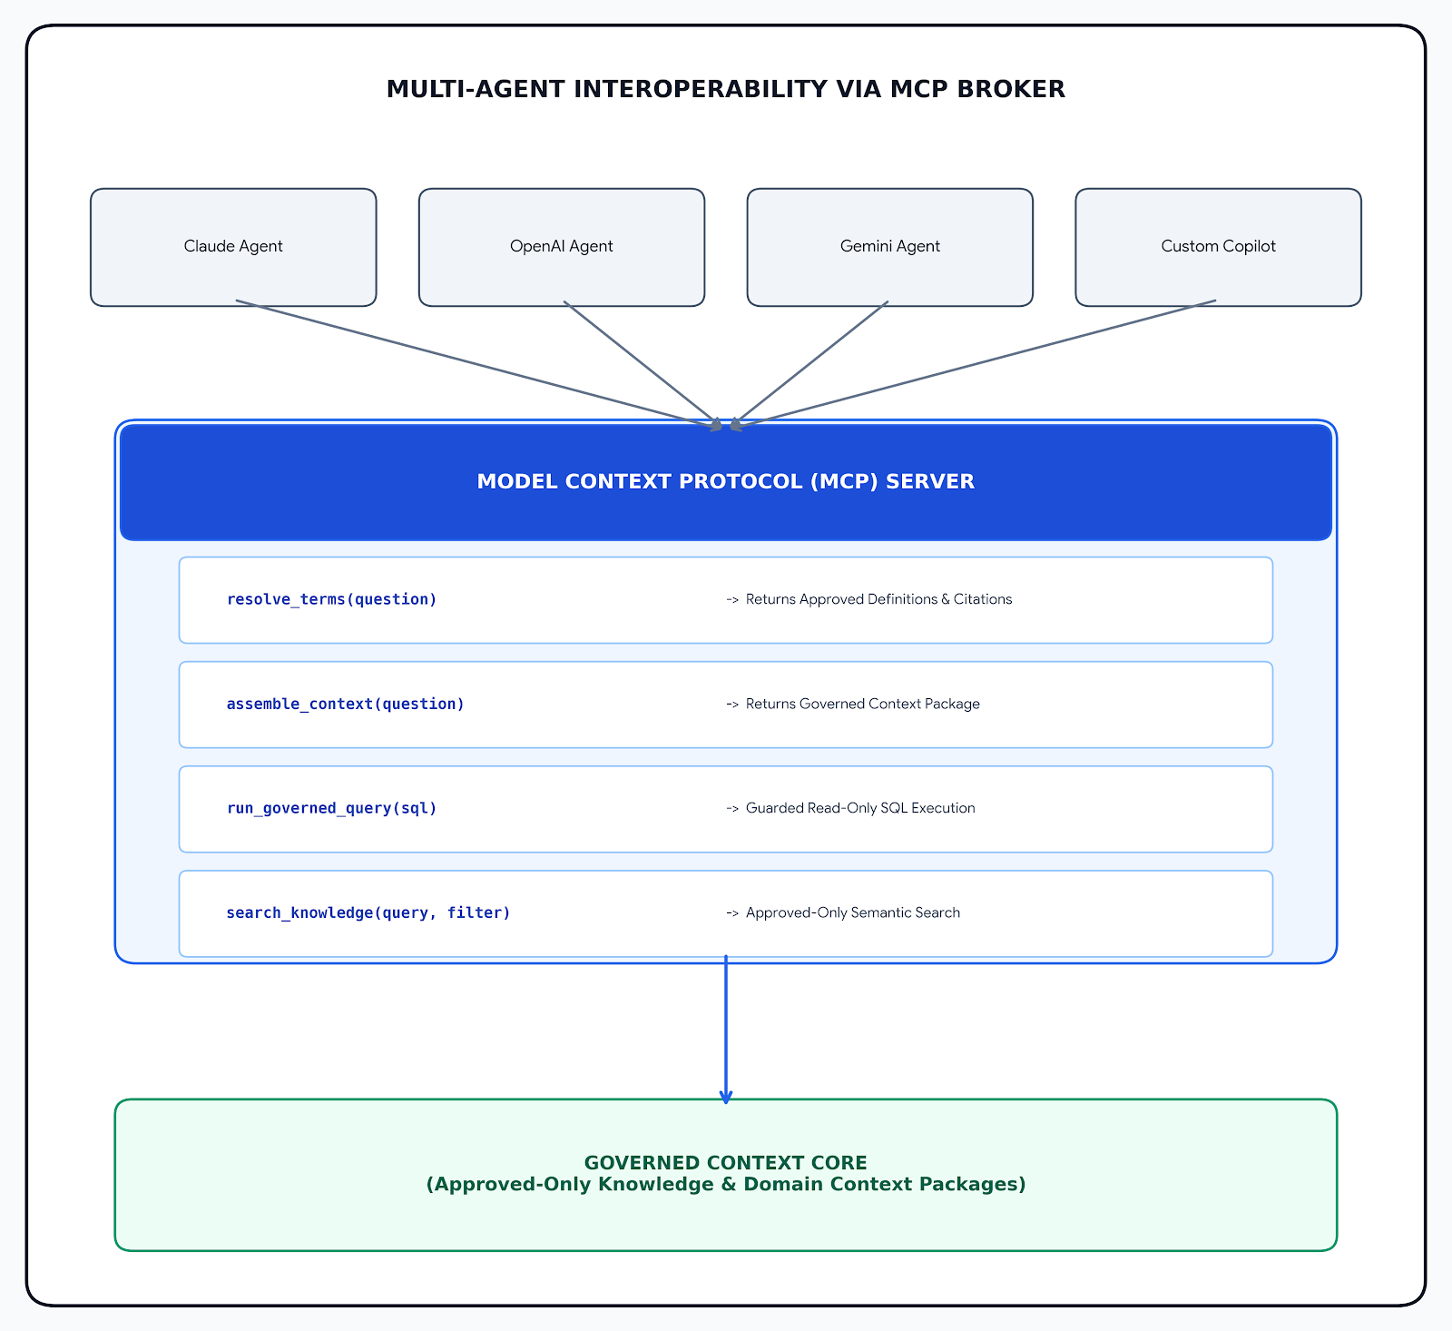

Architectural Components
- External AI Consumer Agents: Third-party LLMs and copilots (Claude, OpenAI, Gemini, custom micro-agents) communicate with CCE without custom integrations or bypassing governance rules.
- Model Context Protocol (MCP) Server: Serves as the central broker providing standardized tools for context retrieval, term resolution, and guarded database execution:
  - resolve_terms(question): Resolves ambiguous surface terms to approved canonical definitions with source citations.
  - assemble_context(question): Assembles the governed context package (glossaries, entity subgraphs, rules).
  - run_governed_query(sql): Executes read-only, guarded SQL queries against enterprise warehouses with timeout limits.
  - search_knowledge(query, filter): Performs semantic searches over human-approved knowledge assets.
- Governed Context Core: Provides underlying storage and execution boundaries for human-approved domain context packages.

17. Governance & Trust Spine
Governance is embedded throughout every layer of CCE:
- Entitlement & DLP Enforcement: User access permissions and DLP redaction rules are captured during ingestion and strictly enforced at retrieval.
- Continuous Epistemic Evaluation: Every context or model update triggers automated regression runs against the benchmark suite to verify context lift.
- Observability & Auditability: Full telemetry tracking via Langfuse and event streams, surfacing token usage, latency, query costs, and user approval logs.

18. Product Principles
# | Principle | Operational Realization
P1 | Governed, not just retrieved. | Only status=approved knowledge is eligible at answer time.
P2 | Prove the lift, always. | Every question executes Context OFF vs ON side-by-side.
P3 | Resolve ambiguity to canonical meaning. | Term conflicts are surfaced and pinned to approved enterprise definitions.
P4 | Everything is traceable. | Claims cite exact documents/versions; numbers cite validated SQL/views.
P5 | Humans own the knowledge. | Machines propose; humans approve. System behavior changes only on human sign-off.
P6 | The engine is domain-blind. | Core logic contains zero hardcoded domain terms; logic lives in swappable context packages.
P7 | Least privilege at the boundary. | Read-only warehouse roles, SELECT-only SQL guards, scoped API keys.
P8 | The knowledge learns. | Reviewed Q&A feedback is promoted into verified procedural SQL templates.

19. In-Scope Product Capabilities
- Multi-Source Connectors: Connectors for Google Workspace (Gmail, Drive, Docs, Sheets), Snowflake, Databricks, PostgreSQL, and BigQuery.
- Governed Context Core Studio: Asset management interfaces for Glossaries, Semantic Models, Knowledge Graphs, and Ambiguity Registers.
- Swappable Domain Package Engine: Authoring, testing, versioning, and hot-swapping framework for domain-specific context packages.
- Dual-Path Proof Runtime Engine: Side-by-side comparative execution of Context OFF vs Context ON with visual diff generation.
- MCP Server Implementation: Complete tool bindings enabling external AI agents to consume governed domain context safely.

20. Future Product Scope & Strategic Roadmap
- Autonomous Semantic Drift Detection: Real-time background scanners that alert stewards when underlying warehouse schemas drift from approved domain semantic models.
- Bi-Directional Action Verification: Extending MCP tools to validate downstream action execution against domain governance policies before execution.
- Multi-LLM Cost & Quality Evaluator: Automated routing that dynamically selects the optimal LLM based on context complexity and token budget constraints.

21. Economic Impact & Long-Term Vision
- Elimination of AI Rework: Reduces post-deployment AI engineering rework by eliminating hallucinated SQL and incorrect business assumptions.
- Rapid Multi-Cloud Onboarding: Enables enterprise teams to onboard new AI agents in hours rather than months by connecting to a pre-governed MCP domain context broker.
- Universal Audit Readiness: Provides instantaneous compliance auditing across all AI-driven business decisions through complete source lineage.
22. Success Measures
To evaluate the operational impact, epistemic precision, and governance efficacy of the CoStrategix Context Engine (CCE), platform success is measured across four primary categories:

1. Epistemic Quality & Accuracy Measures
- Context Accuracy Lift Ratio: Sustained achievement of >80% query accuracy for Context ON execution compared to < 40% for the Context OFF baseline across enterprise benchmark test suites.
- Zero Unapproved Leakage: 100% compliance with the invariant that zero proposed or unapproved knowledge assets are ever served at query runtime or via Model Context Protocol (MCP) endpoints.
- Citation & Lineage Traceability: 100% of generated answers, metric calculations, and SQL queries carry explicit, auditable citations back to source documents, schema views, and version tags.

2. Operational & Engineering Efficiency Measures
- AI Rework Reduction: 60% reduction in post-deployment AI engineering rework caused by hallucinated SQL, unhandled edge cases, or ambiguous business definitions.
- Agent Onboarding Velocity: 70% reduction in time required to integrate and deploy new autonomous AI agents by leveraging CCE as a pre-governed MCP context broker.
- SQL First-Pass Execution Rate: > 90% first-pass execution success rate on generated SQL queries without requiring self-repair or schema retry loops.

3. Domain Governance & Lifecycle Metrics
- Canonical Coverage Index: Percentage of enterprise domain metrics, core acronyms, and ambiguous terms backed by human-approved canonical definitions.
- Steward Review Throughput: Average time taken by human domain owners to review, edit, and approve machine-proposed terms in the review queue.
- Conflict Resolution Efficiency: 100% resolution rate of identified cross-domain term collisions recorded and pinned in the Ambiguity Register.

Long-Term Vision: CoStrategix Context Engine (CCE) will become the cognitive infrastructure for the AI-driven enterprise. By decoupling domain logic from underlying data storage and AI model vendors, CCE ensures that as AI models evolve, an organization's language, rules, and operational intelligence remain permanently governed, fully auditable, and owned entirely by humans.

